Supplementary Online Content

The potential long-term comparative effectiveness of larotrectinib vs. entrectinib for treatment of metastatic NTRK fusion colorectal cancer, soft tissue sarcoma, and baseline brain metastasis

eFigure 1. One-way sensitivity analysis for larotrectinib vs. entrectinib on QALYs gained in colorectal cancer
eFigure 2. One-way sensitivity analysis for larotrectinib vs. entrectinib on QALYs gained in soft tissue sarcoma
eTable 1. Sensitivity analysis fitting an exponential curve through the median points for progression-free and overall survival for entrectinib

eFigure 1. One-way sensitivity analysis for larotrectinib vs. entrectinib on QALYs gained in colorectal cancer
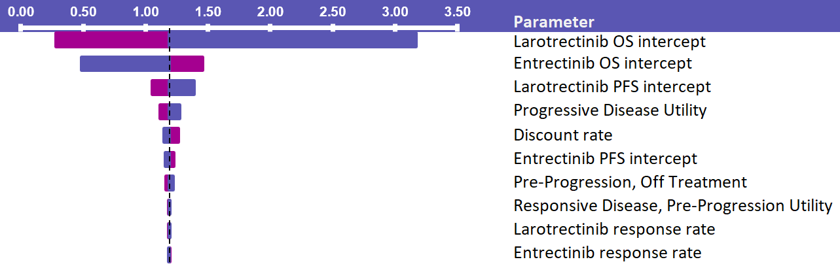

eFigure 2. One-way sensitivity analysis for larotrectinib vs. entrectinib on QALYs gained in soft tissue sarcoma
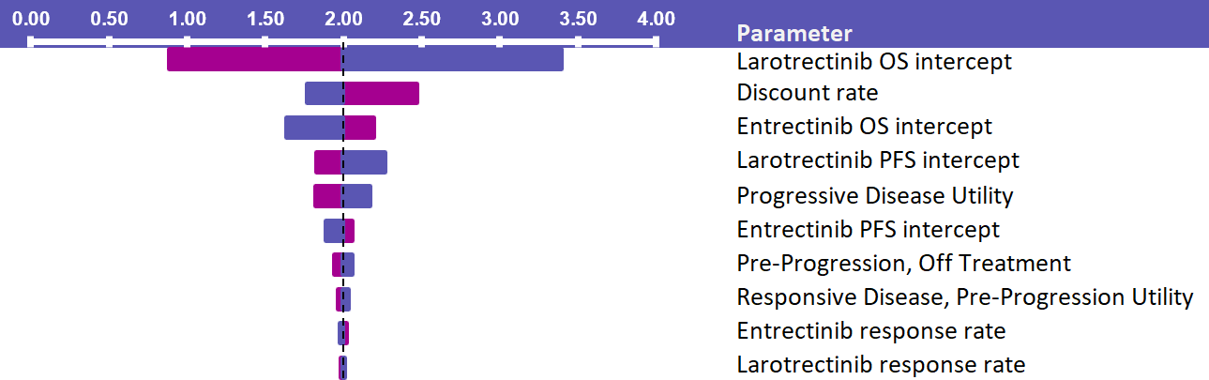

eTable 1. Sensitivity analysis fitting an exponential curve through the median points for progression-free and overall survival for entrectinib
 | Colorectal cancer | Soft tissue sarcoma
Progression-free life-years | 0.29 | 1.19
Post progression life-years | 1.56 | 0.75
Total | 1.85 | 1.93
Progression-free QALYs | 0.24 | 0.59
Post progression QALYs | 1.00 | 0.22
Total | 1.24 | 0.82
QALY: quality-adjust life-year

